**Website Certificate Management:**

1. First check if the package is already on the system. This is the package needed to generate the certificates.
2. Use command yum install mod_ssl (SSL 🡪 secure socket layer)
3. 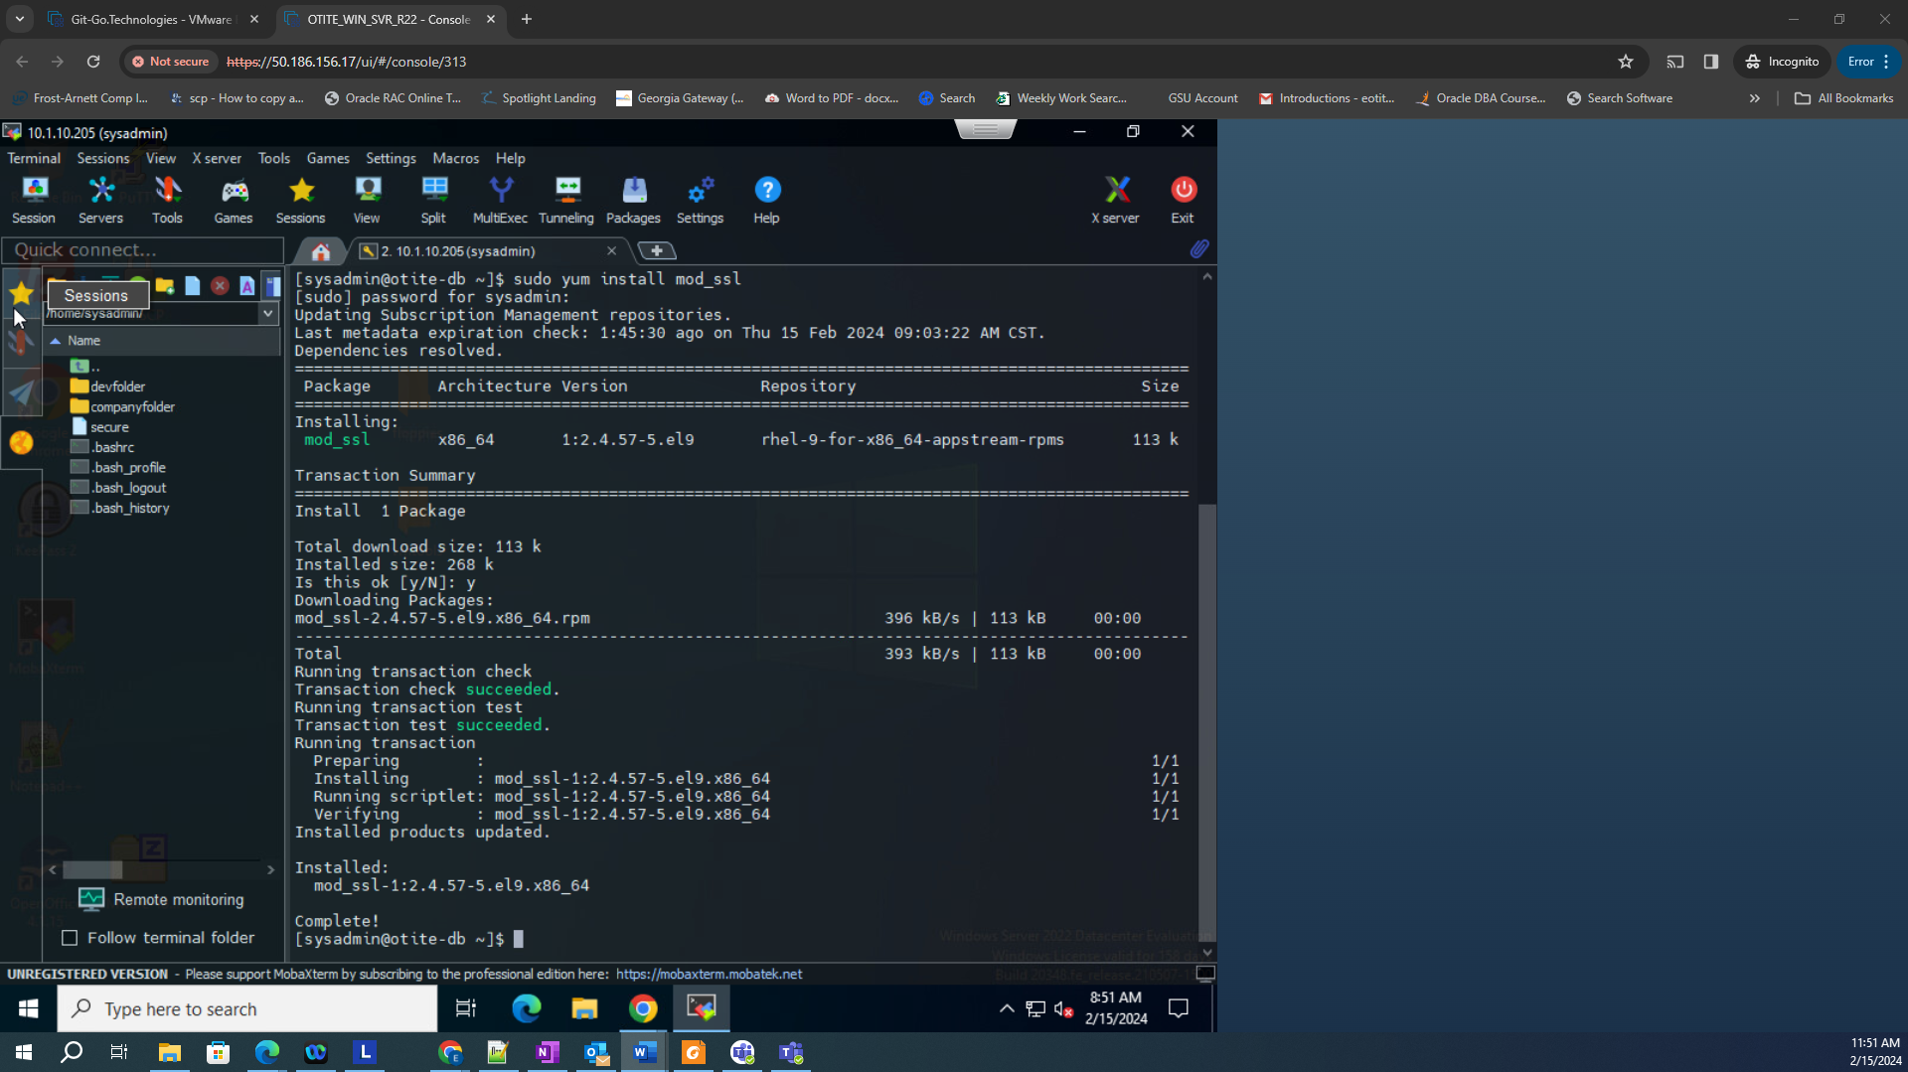
4. Next verify if we have the configuration file available by command cd/etc/httpd/conf.d:
5. 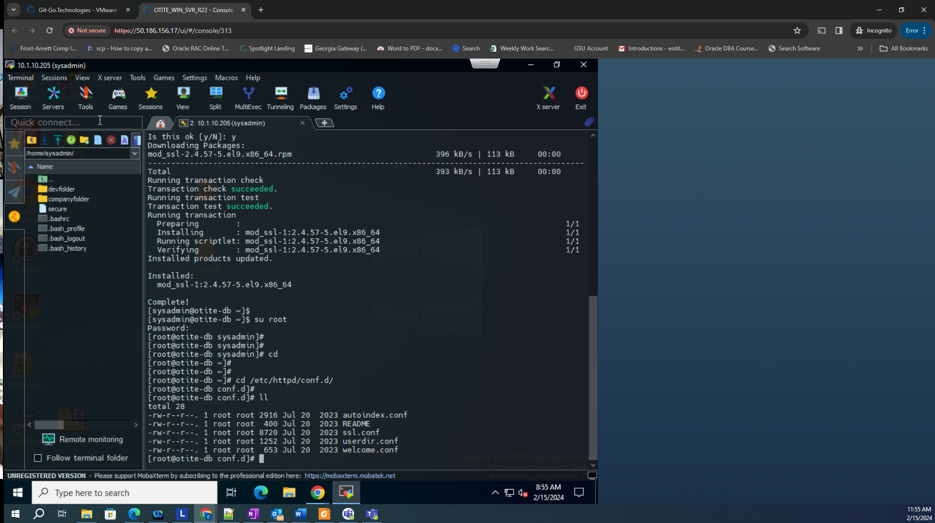
6. For the next step we need a package called openssl. This is needed to generate an SSL key and self-sign certificate: using command yum install openssl -y (-y because it will override what we have and there is no need to just check). This is require for the public and private kets:
7. 
8. Make sure you are not in the home directory for the next step. When you want to generate the key, it is important to note where the keys need to be generated. So cd into /etc/pki/tls
   1. PKI (Public Key Infrastructure)
   2. TLS (Transfer Layer Secure)
9. 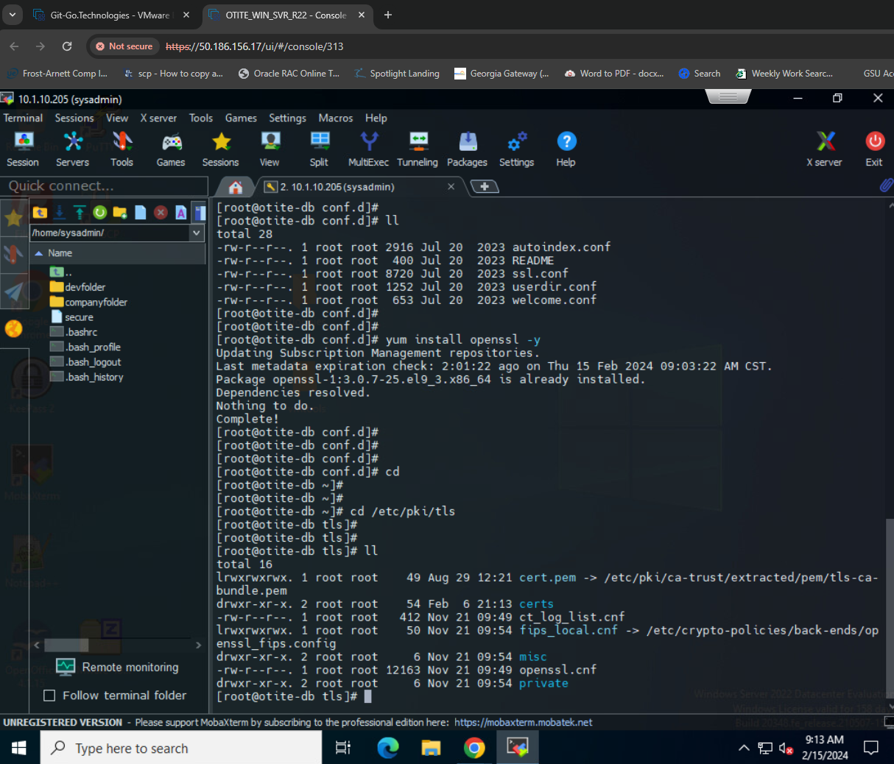
10. Command openssl genrsa -out jevwe.key 2048
11. 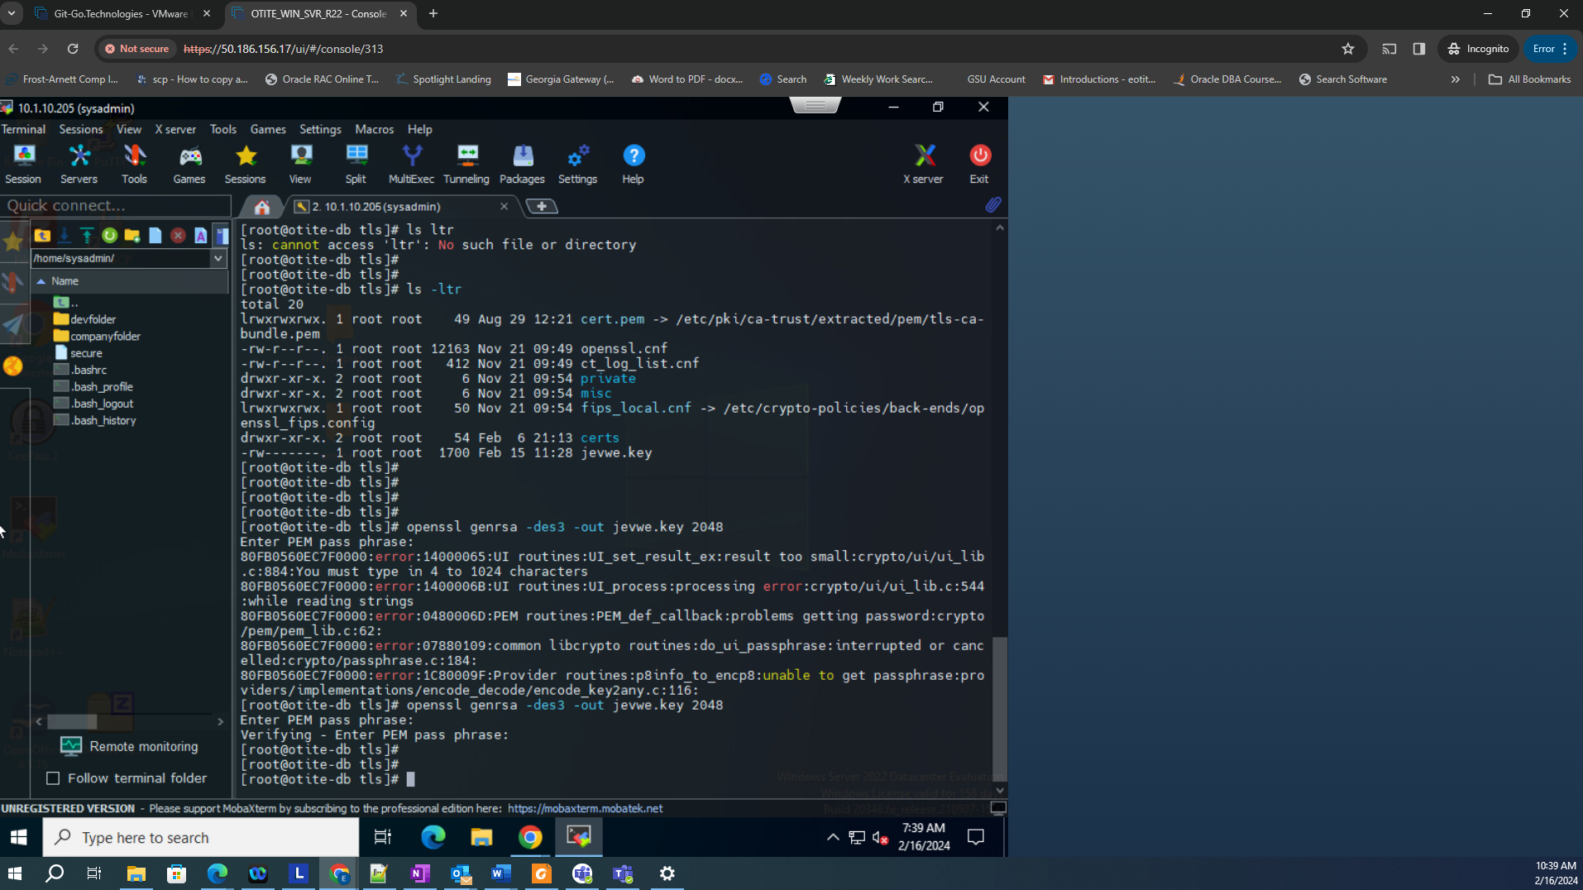
12. Run cd /etc/pki/tls/certs/
13. 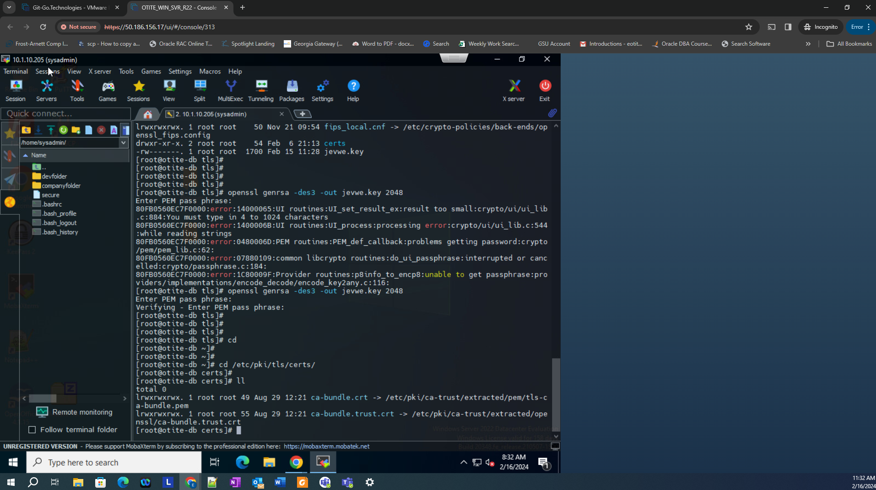
14. Regenerate new keys: cmd 🡪 openssl req -new -x509 -nodes -sha1 -days 365 -key /etc/pki/tls/private/jevwe.key -out jevwe.crt
15. Errorred
16. 
17. Missed permissions: chmod 600 on file
18. 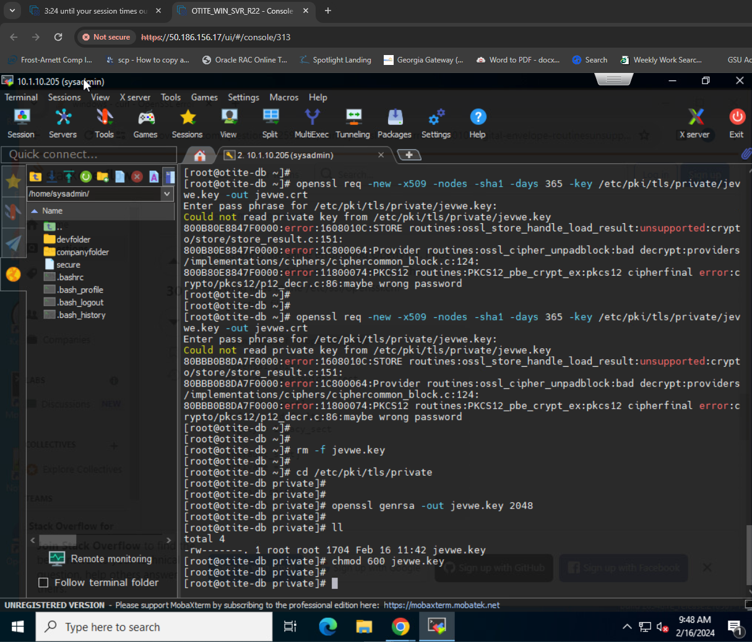
19. 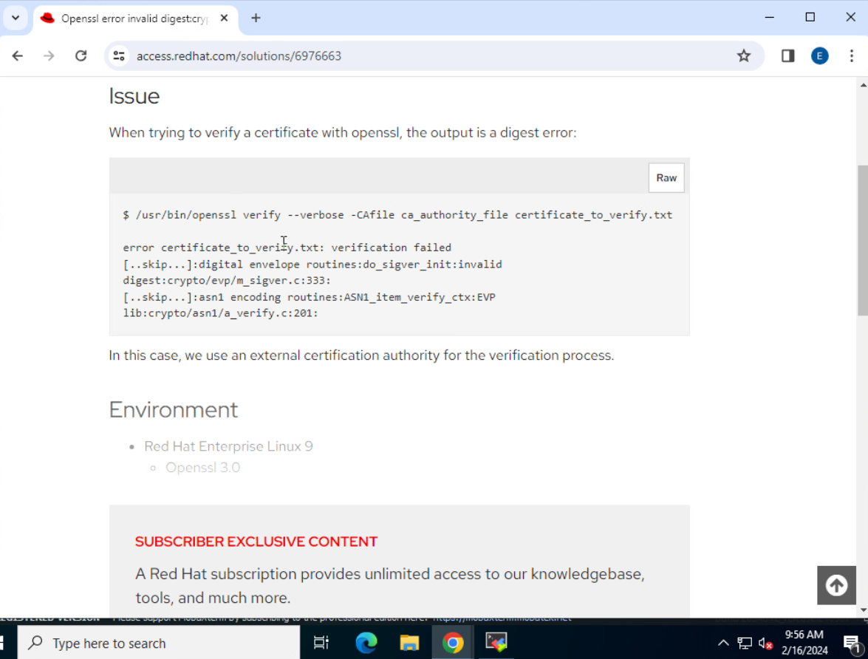
20. Resolution: Check your crypto policy in use
21. 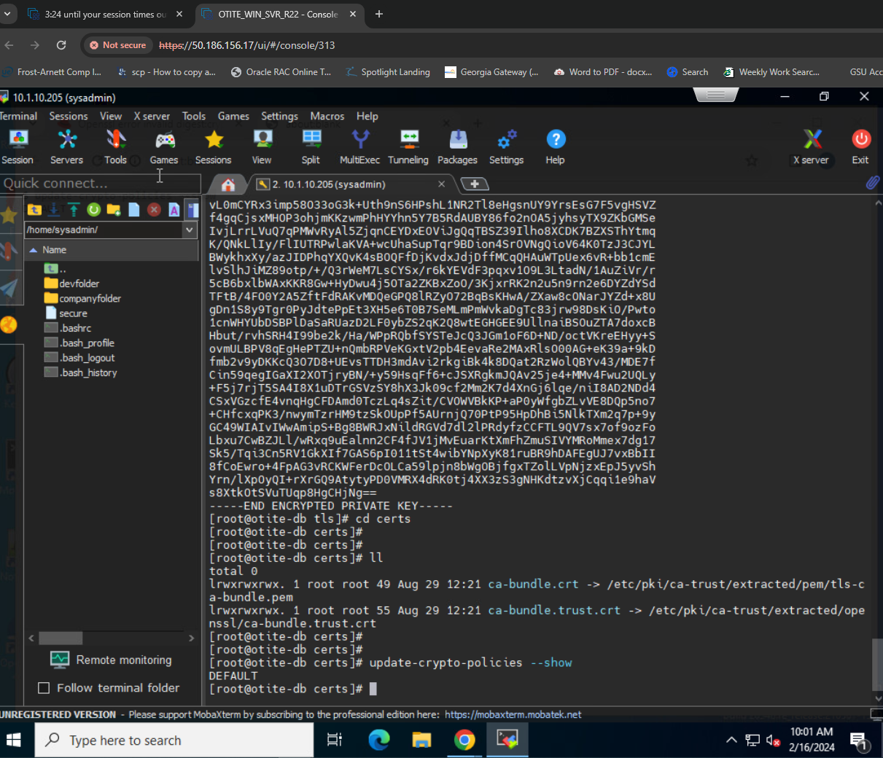
22. SHA-1 no longer supported on RHEL 9:
23. 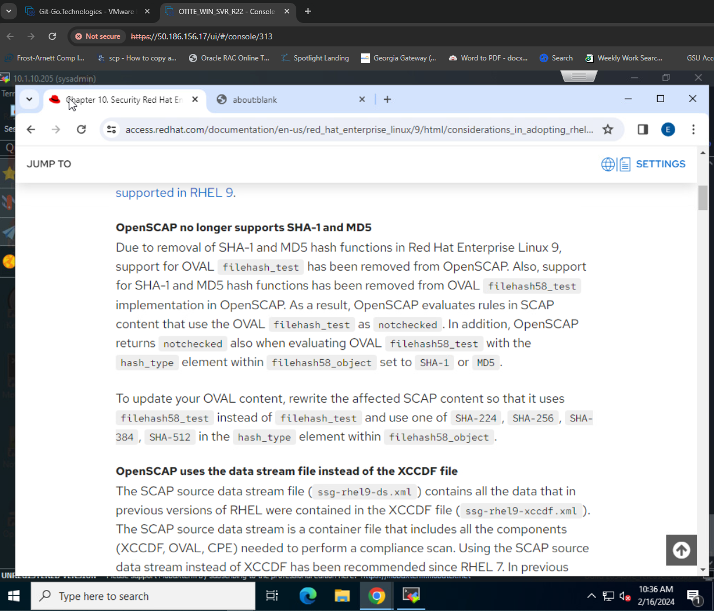
24. Success!! 😊
25. 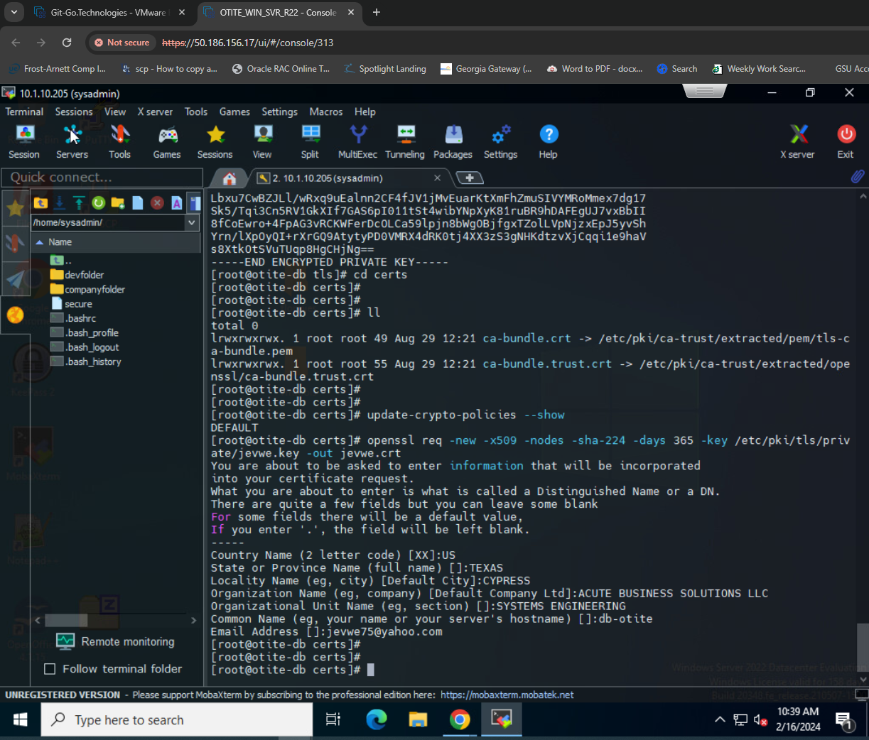
26. Now install the certificate by updating the file under vi /etc/httpd/conf.d/ssl.conf
27. 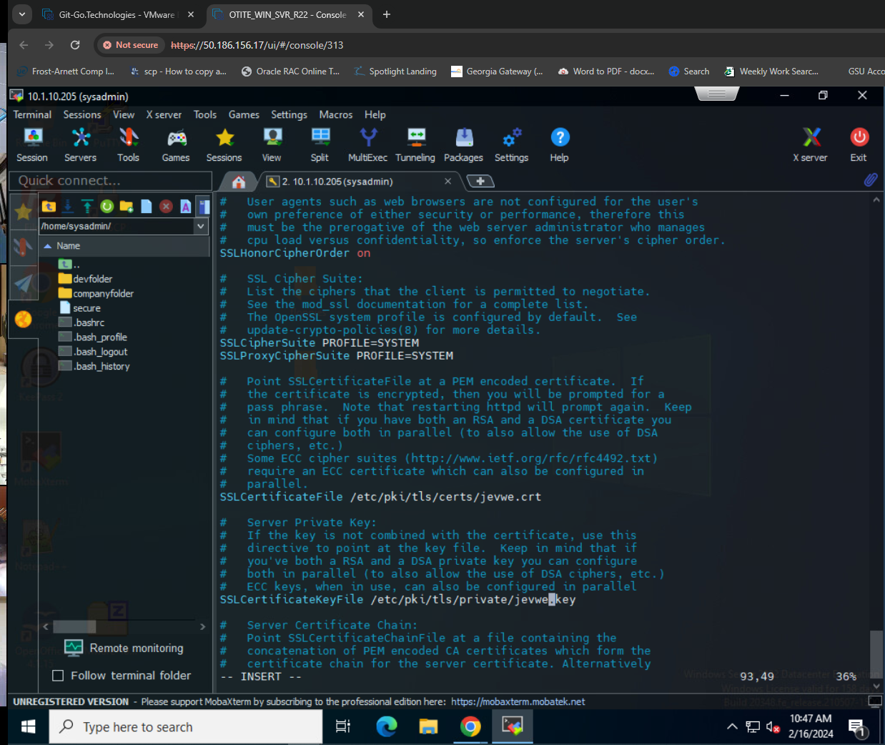
28. Restart the service with systemctl restart httpd
29. 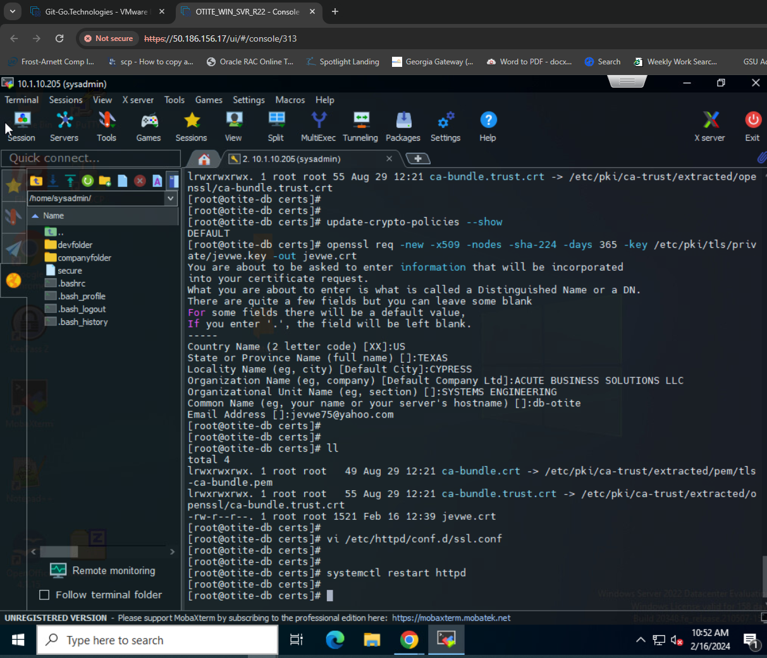
30. 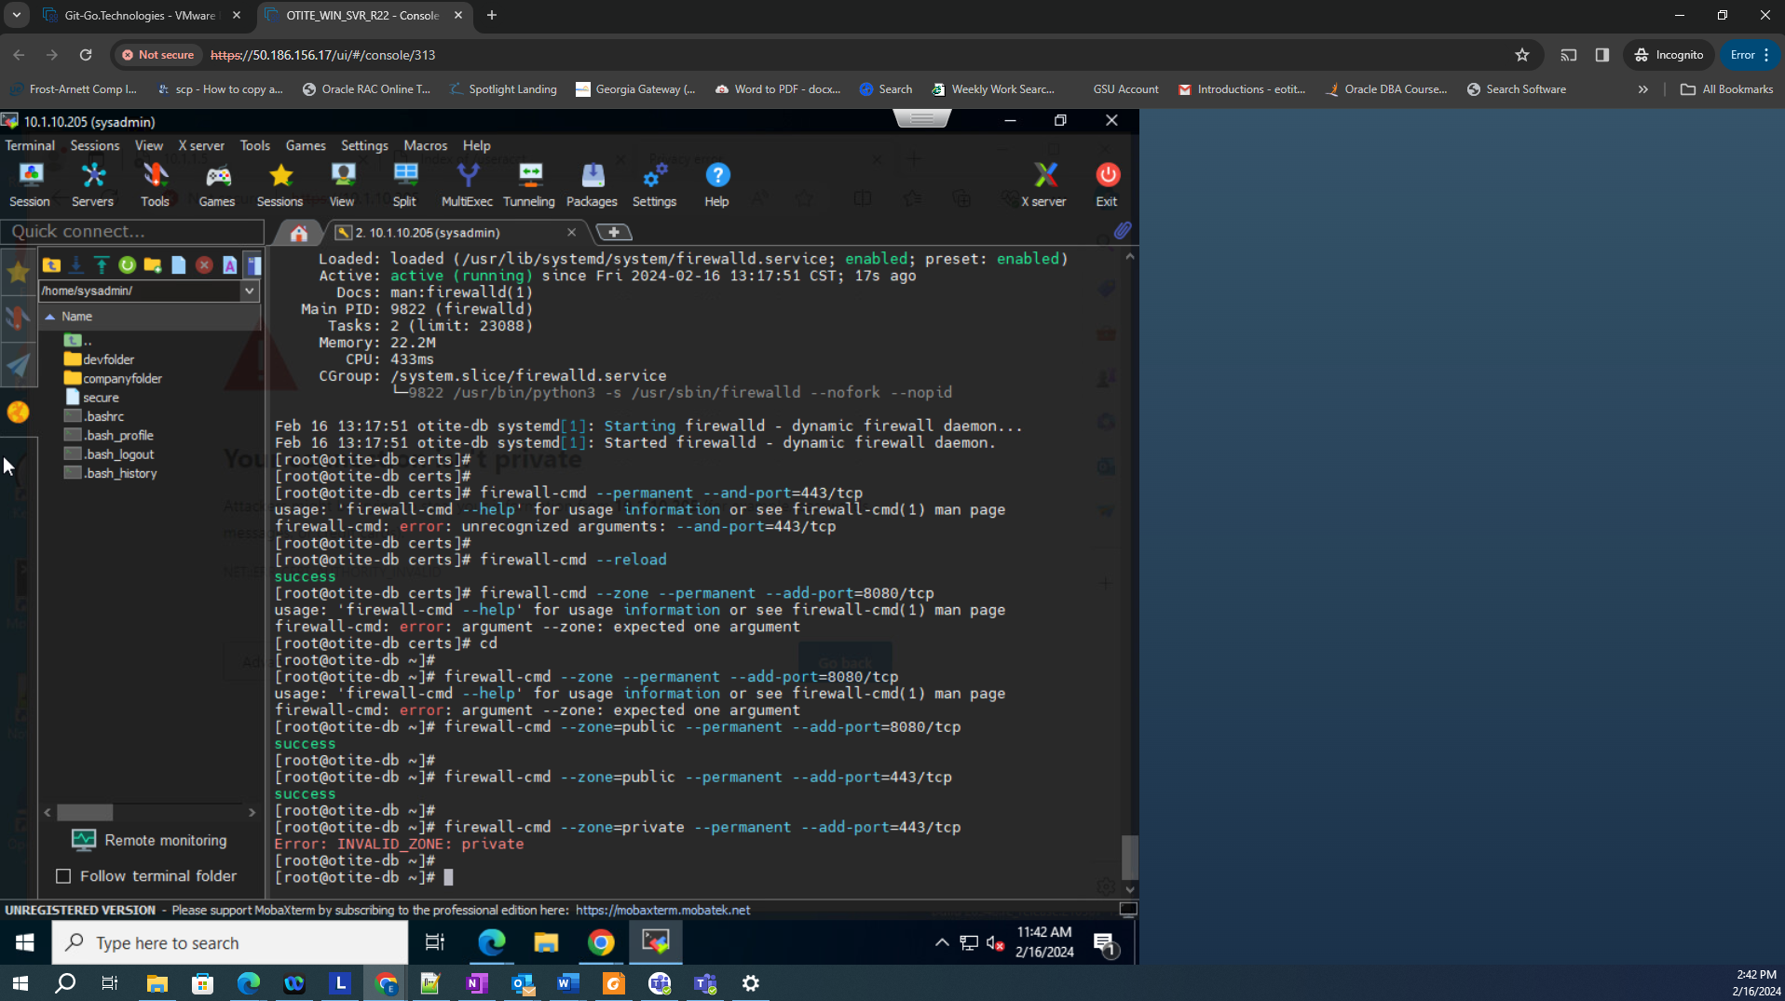
31. 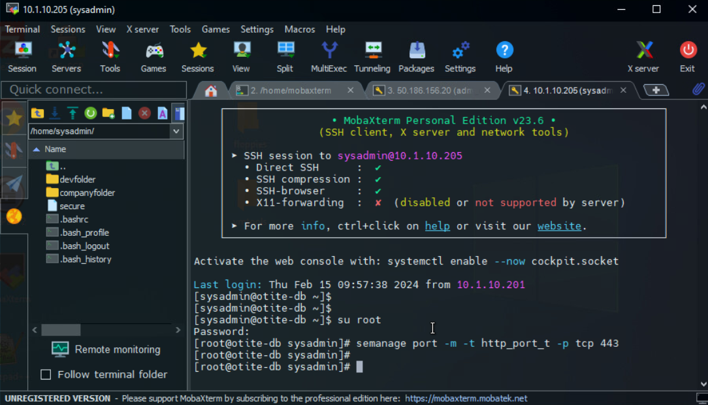
32. Reload daemon:
33. 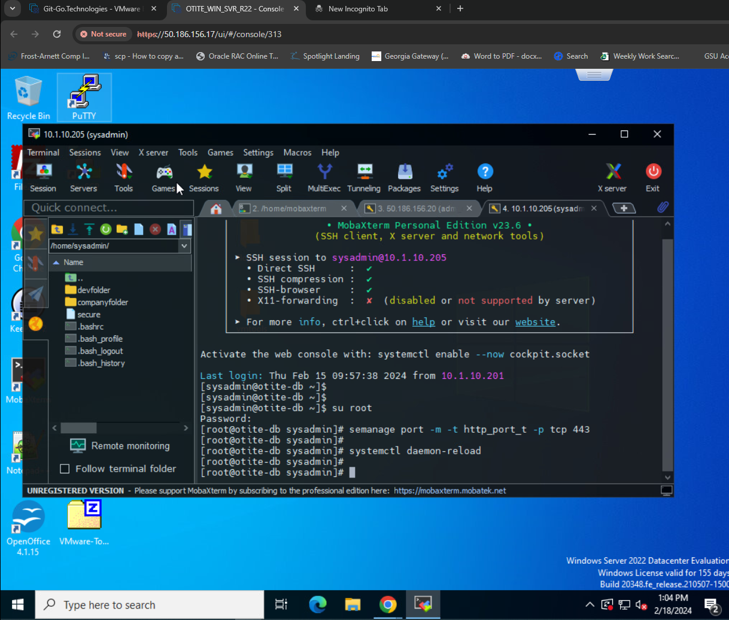
34. 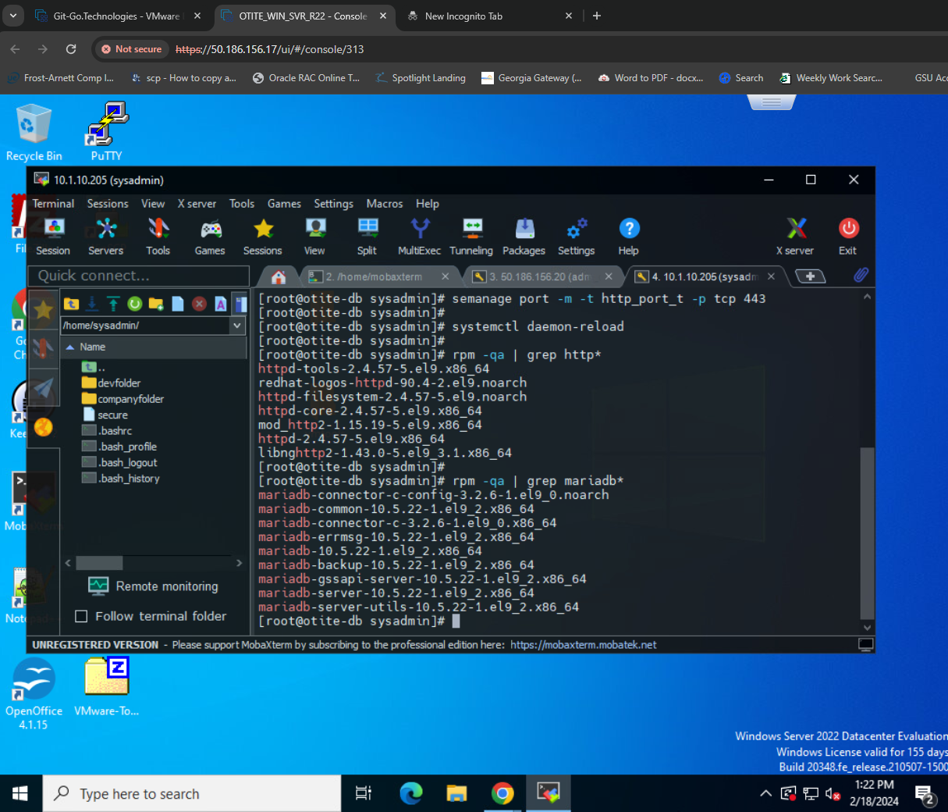
35. Check packages and grep into a file:
36. 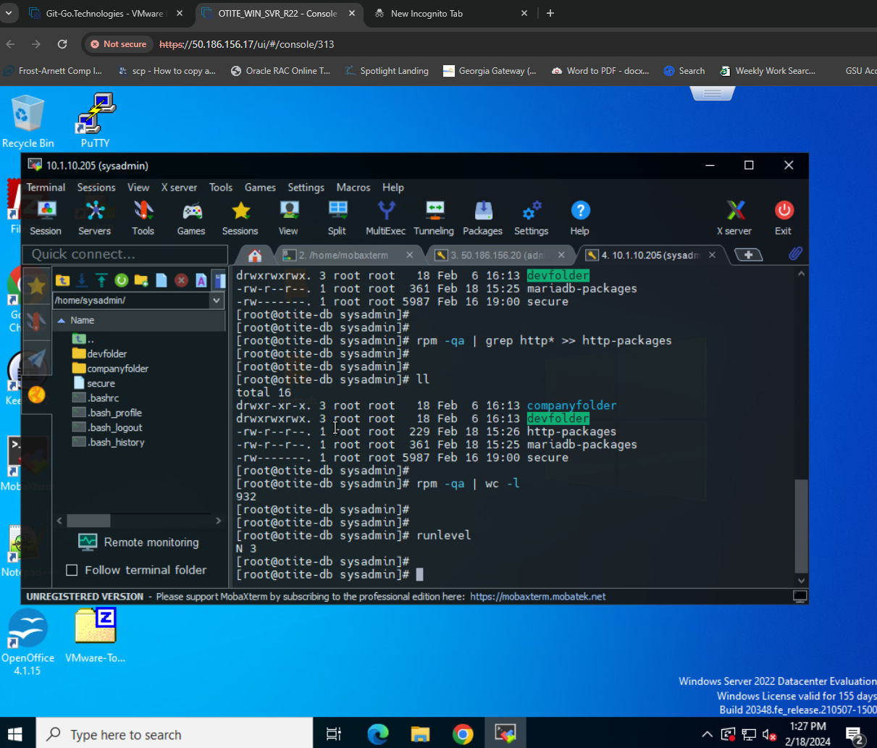
37. Word count rpm -qa | wc -l
38. 
39. Install GUI:
40. 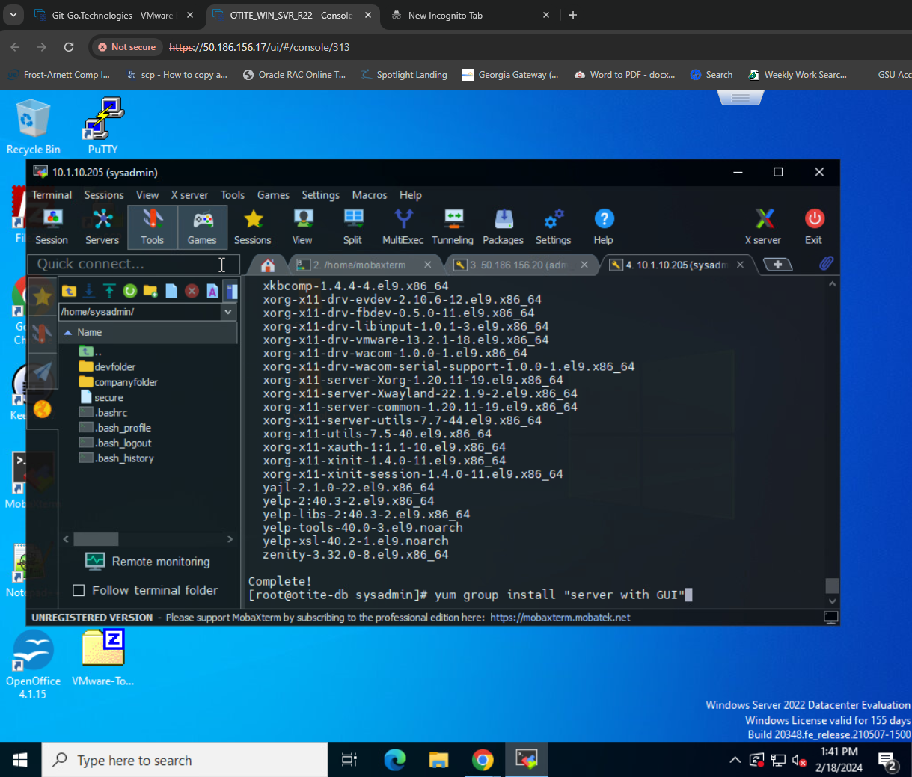
41. GUI on the console:
42. 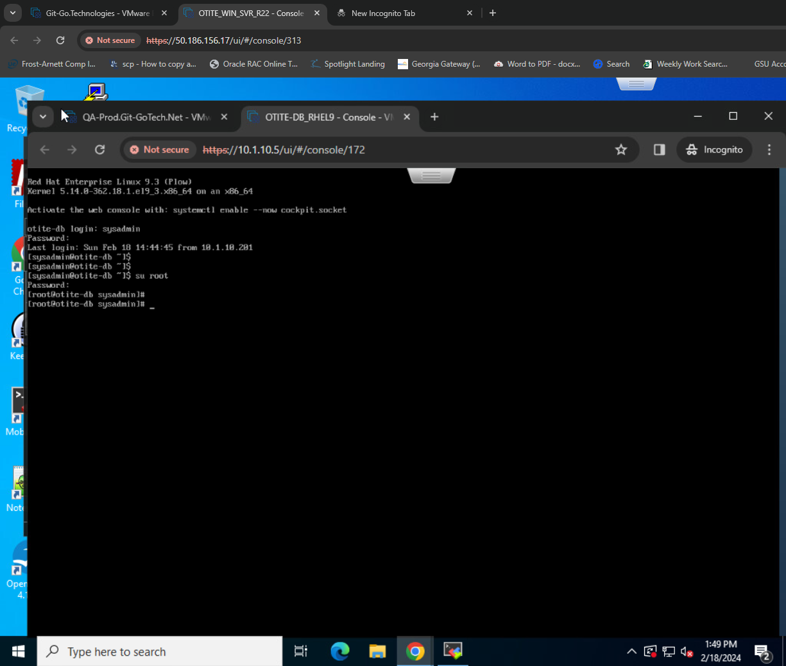
43. 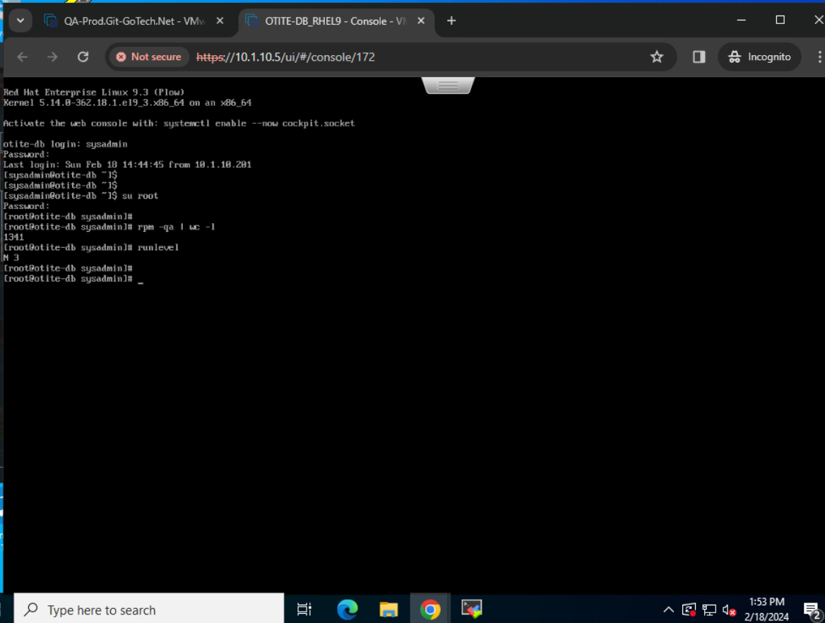
44. 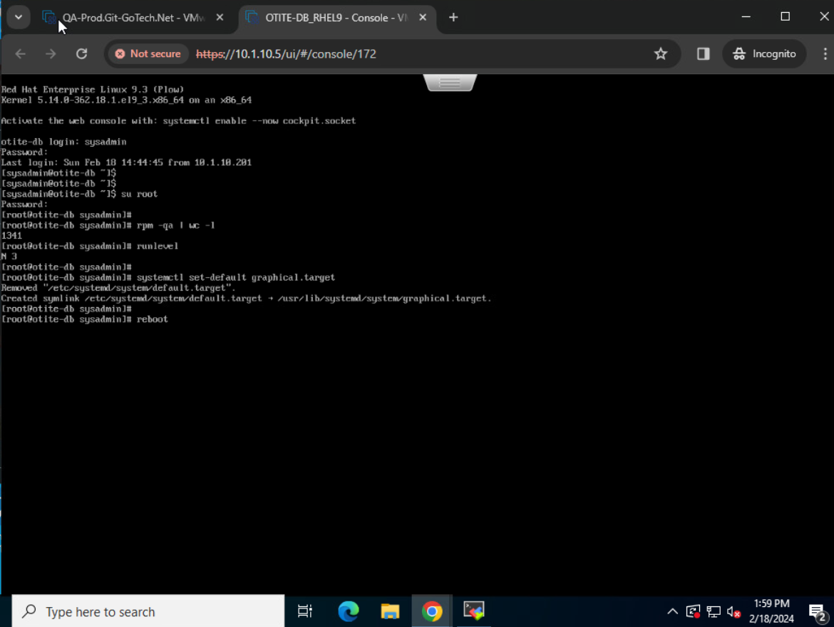
45. 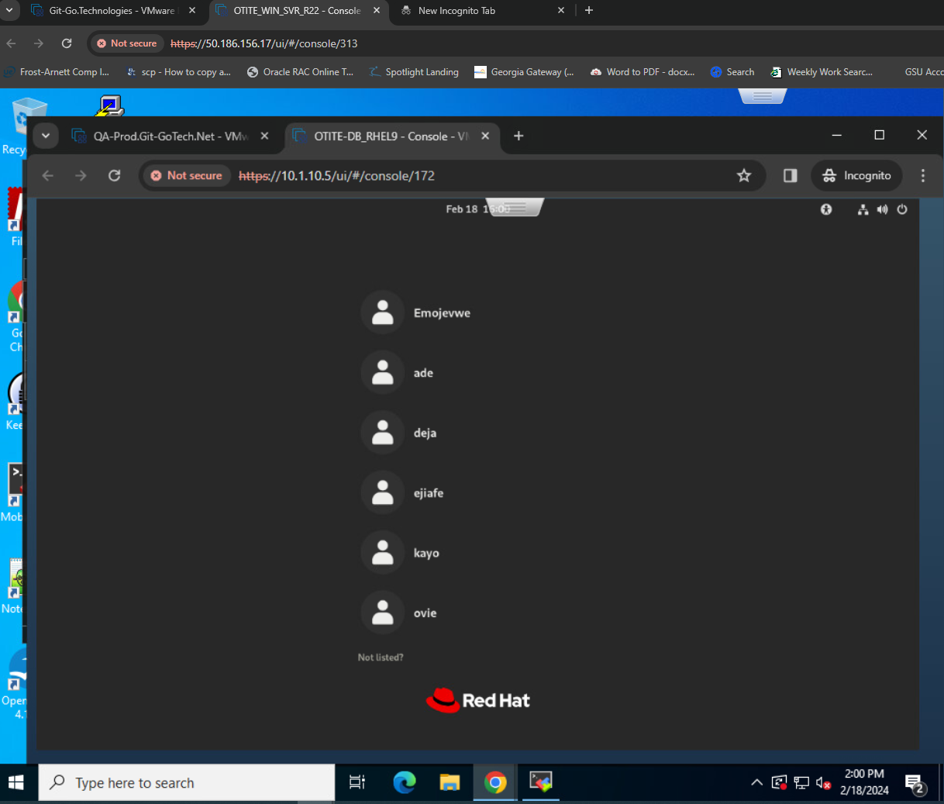
46. 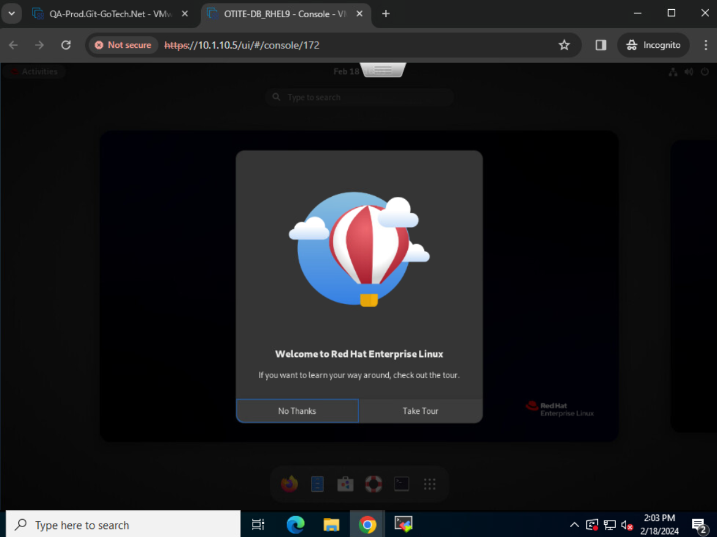
47. 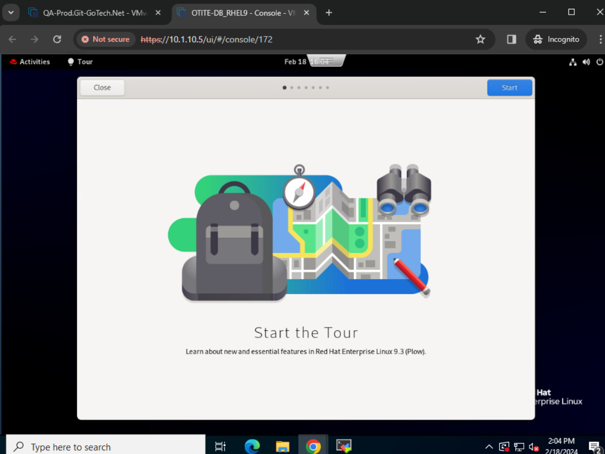
48. 
49. 
50. 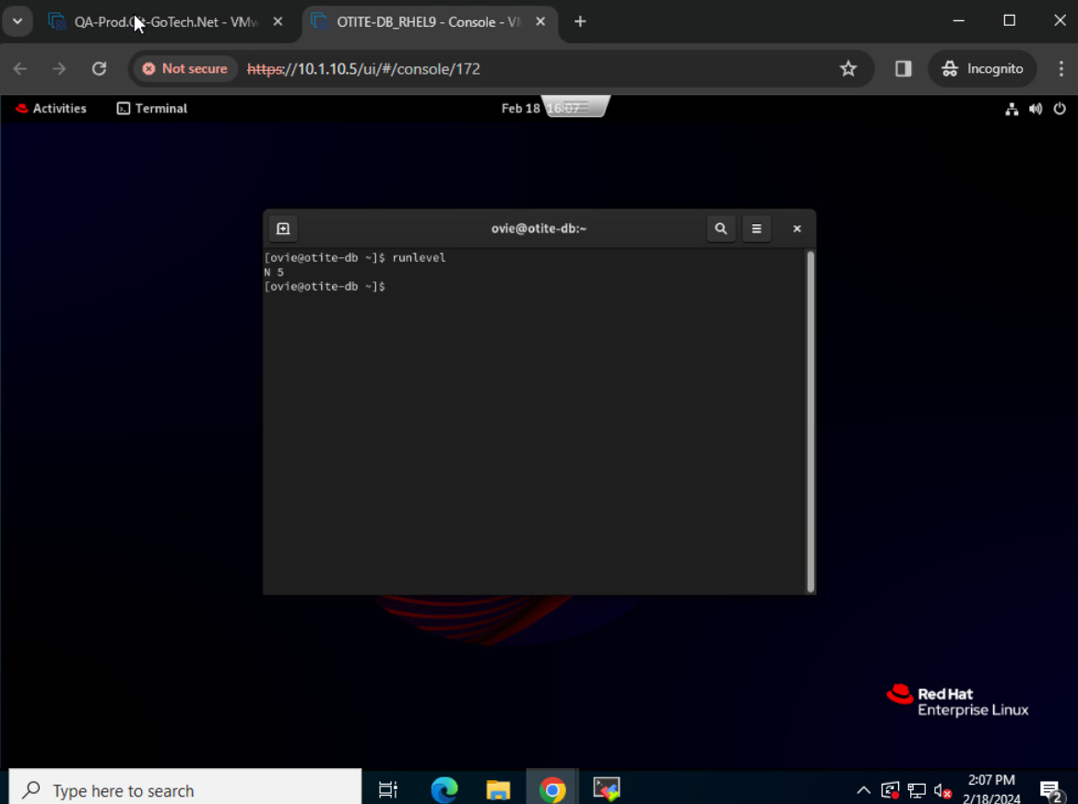
51. 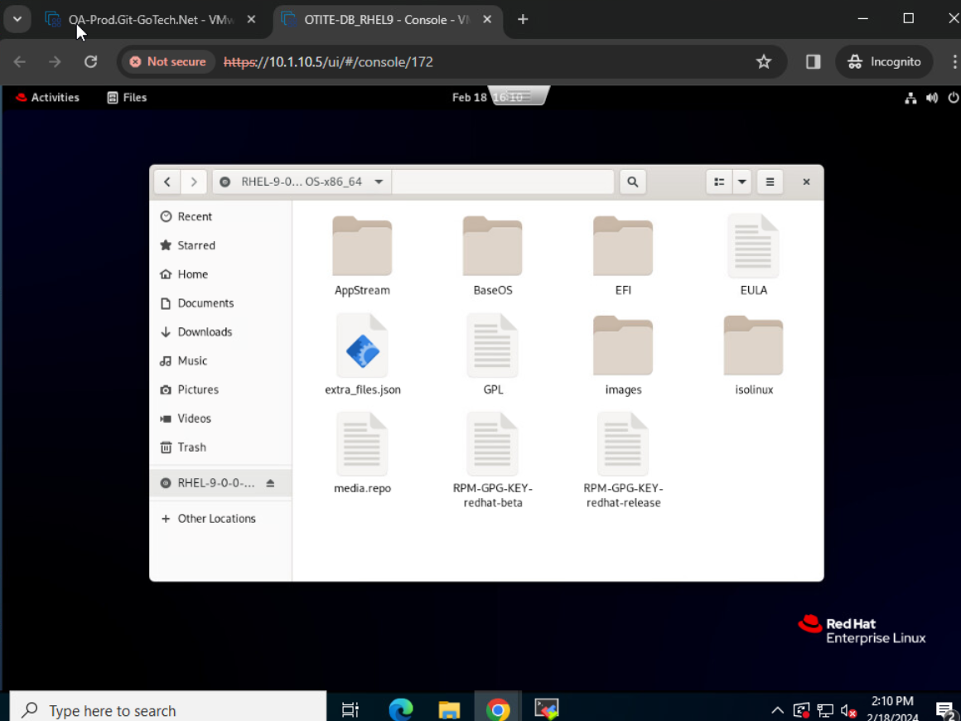
52. 
53. 
54. 